Personnel Disciplinaries:

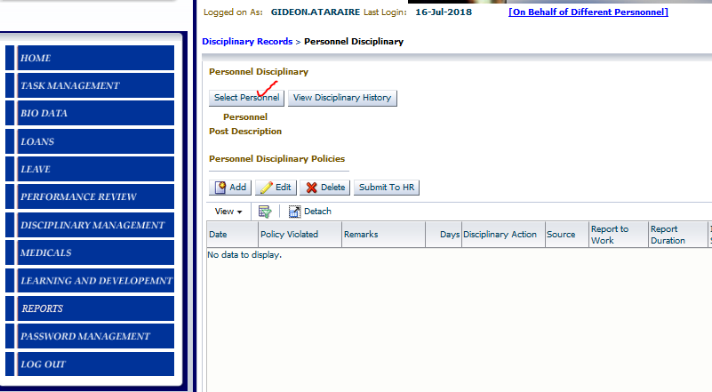

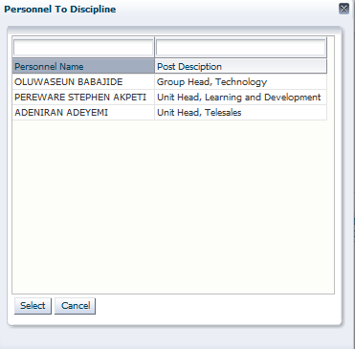

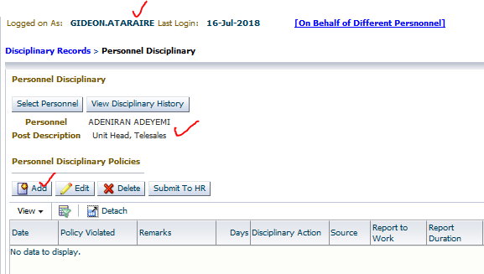

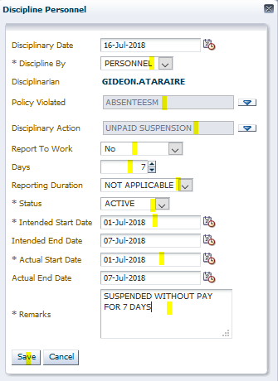

System should deduct pay for the 7 days when the employee was suspended without pay. Proration parameters apply as set up (denominator = 22).

Error saving record:

